Clinic Inventory System
Final Project
Course Code: CPE 201L | Program: BSCPE
Course Title: Data Structures and Algorithms | Date Performed: 11/08/2025
Section: CpE-2B | Date Submitted: 11/08/2025
Leader: Aquino, Jester J.  Members:  Caasi, Karl  Elpedes, Glen  Monoy, Justin Rhey  Tan, Charles | Instructor: Engr. Maria Rizette Sayo
1. Objective(s):
The main goal of this project is to design and develop an efficient system that accurately manages and monitors the clinic’s medical supplies, equipment, and resources.

This is accomplished by two major objectives:

- To efficiently manage and organize clinic inventory to ensure fast storage, retrieval, and updating of medical supply records.

- To automate and optimize the inventory process minimizing human errors, improving accuracy, and providing real-time information for better decision-making and resource management.

2. Intended Learning Outcomes (ILOs):
- Understand the concept and importance of using arrays in managing and organizing clinic inventory data such as medicines, equipment, and supplies.
- Apply basic data structure principles, particularly arrays, to store, retrieve, and update inventory records efficiently.
- Adding a simple script to handle inventory transactions like adding, deleting, and searching.
- Strengthen skills in Python programming and system design through the practical use of arrays.
- Analyze the efficiency and accuracy of the system in managing real-world clinic operations.

3. Discussion:
The Clinic Inventory System is designed to help our medical facilities manage their supplies, medicines, and equipment efficiently. In many clinics, manual inventory tracking often leads to errors, misplaced items, and inaccurate stock levels. Through the use of a computerized system, managing inventory becomes more organized, accurate, and time-saving.
This system allows users to record essential information such as item names, quantities, expiration dates, and categories. It also provides basic functions like adding new items, updating existing records, searching for specific items, and deleting outdated entries. By automating these processes, the system minimizes human error and improves record accuracy.
Moreover, this project enhances students’ understanding of how data can be structured, stored, and managed within a system. It demonstrates how programming and logical organization can be applied to solve real-world problems in the healthcare setting. The Clinic Inventory System not only promotes efficiency in operations but also ensures that clinics maintain adequate supplies to provide continuous and effective patient care.
4. Materials and Equipments:
1. PyCharm
- Is an Integrated Development Environment (IDE) for python.
2. Google Colab
- It allows users to write and execute Python in browser
3. Desktop/laptop
- Use for
4. Microsoft Word
- Use for writing the details and explanation of the python codes
5. Desktop/laptop
- Use for making the tasks needed
6. Windows 10/11
- Use to run necessary programs for python programming

5. Procedure:
Step 1: Start the application (cursor).
Step 2: Get the tools ready by importing all tools needed to build the program
Step 3: Make it look nice by sets the color theme and appearance
Step 4: Create an empty storage boxes like two empty list to store data (example medicine and equipment)
Step 5: Add a New medicine like adding new product to your inventory list
Step 6: Insert Medicine at the Beginning
Instead of adding at the end, you can add at position 0 (the very beginning)
all other medicines get pushed down
Step 7: Remove Medicine by ID
Step 8: Update Existing Medicine
Program loads the medicines data into the input fields
Step 9: Search by name
Step 10: Find by ID
Program goes through the list one by one
Check if ID matches
Returns the medicine when found
Step 11: Sort Medicines
Programs rearranges the medicine list alphabetically
Table refreshes to show sorted order
Step 12: Create Tabs
Create two tabs Medicine and Equipment
Step 13: Adding Input fields
Step 14: Highlighting Low Stock
Program checks each medicine in the table
If packs less than or total_qty less than 5 makes row Red
If expiring within 30 days make row yellow
Step 16: Activity Log
Every action is logged with a timestamp
Step 17: Real time clock
Clock in top right corner updates every second

Step 14: End (If no refresh is triggered, the app becomes idle and waits for user input, which restarts the loop at Step 9).

6. Algorithm
- Start the program
- Initialize Medicine[] and Equipment[] arrays
- If “Medicines” is chosen
- Display Options
-Add New
-Update
-Remove
-Search/Filter
-Sort
SS-View
- If Add:
- Input item details
- Add item to array
- If Update:
- Input item name
- Search in array
- Update details if found
- If Delete:
- Input item name
- Search in array
- Remove item if found
- If Search:
- Input item name
- Search in array
- Display details if found
- If Display:
- Show all items in arrays
- Reset to exit
- End

7. FlowChart
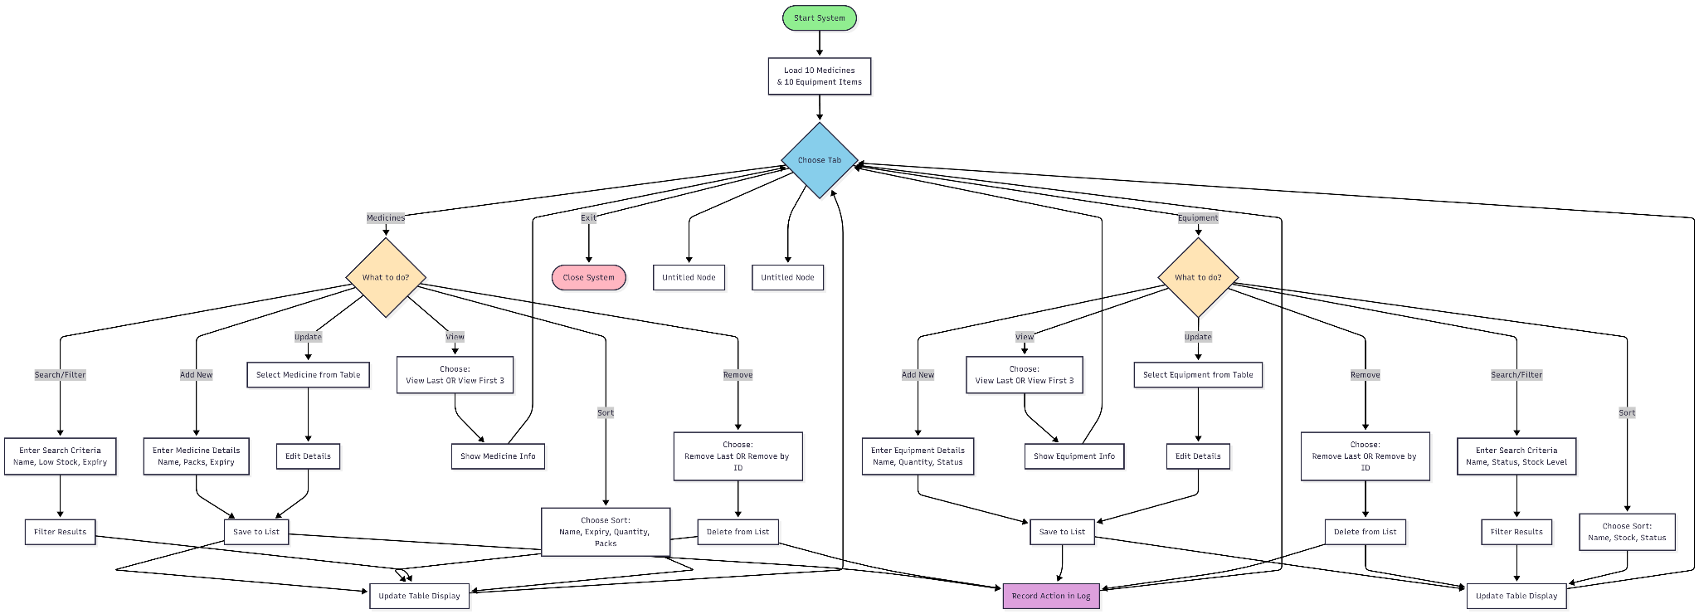

8. Pseudocode

BEGIN
Initialize system
Input tabChoice // Medicines, Equipment, or Exit

IF tabChoice = Medicines THEN
Input medChoice // Add, Update, Remove, Search/Filter, Sort, View, or Back

IF medChoice = Add THEN
Input name, packs, expiry
Add (name, packs, expiry) to MedicineList
UpdateTableDisplay()

ELSE IF medChoice = Update THEN
Input selectedMedicine
Input newName, newPacks, newExpiry
Update selectedMedicine with (newName, newPacks, newExpiry)
UpdateTableDisplay()

ELSE IF medChoice = Remove THEN
Input removeChoice // Remove by ID or Remove Last
IF removeChoice = Remove by ID THEN
Input medicineID
Delete medicine with ID = medicineID from MedicineList
ELSE
Remove last item from MedicineList
ENDIF
UpdateTableDisplay()

ELSE IF medChoice = Search/Filter THEN
Input criteria // Name, Low Stock, Expiry
Filter MedicineList using criteria
UpdateTableDisplay()

ELSE IF medChoice = Sort THEN
Input sortChoice // Name, Expiry, Quantity, Packs
Sort MedicineList by sortChoice
UpdateTableDisplay()

ELSE IF medChoice = View THEN
Input viewChoice // View Last or View First 3
IF viewChoice = View Last THEN
Show last Medicine item(s)
ELSE
Show first 3 Medicine items
ENDIF
ENDIF

ELSE IF tabChoice = Equipment THEN
Input eqChoice // Add, Update, Remove, Search/Filter, Sort, View, or Back

IF eqChoice = Add THEN
Input name, quantity, status
Add (name, quantity, status) to EquipmentList
UpdateTableDisplay()
RecordActionInLog()

ELSE IF eqChoice = Update THEN
Input selectedEquipment
Input newName, newQuantity, newStatus
Update selectedEquipment with (newName, newQuantity, newStatus)
UpdateTableDisplay()
RecordActionInLog()

ELSE IF eqChoice = Remove THEN
Input removeChoice // Remove by ID or Remove Last
IF removeChoice = Remove by ID THEN
Input equipmentID
Delete equipment with ID = equipmentID from EquipmentList
ELSE
Remove last item from EquipmentList
ENDIF
UpdateTableDisplay()
RecordActionInLog()

ELSE IF eqChoice = Search/Filter THEN
Input criteria // Name, Status, Stock Level
Filter EquipmentList using criteria
UpdateTableDisplay()
RecordActionInLog()

ELSE IF eqChoice = Sort THEN
Input sortChoice // Name, Stock, Status
Sort EquipmentList by sortChoice
UpdateTableDisplay()
RecordActionInLog()

ELSE IF eqChoice = View THEN
Input viewChoice // View Last or View First 3
IF viewChoice = View Last THEN
Show last Equipment item(s)
ELSE
Show first 3 Equipment items
ENDIF
ENDIF

ELSE IF tabChoice = Exit THEN
Stop system
ENDIF

END

9. Output
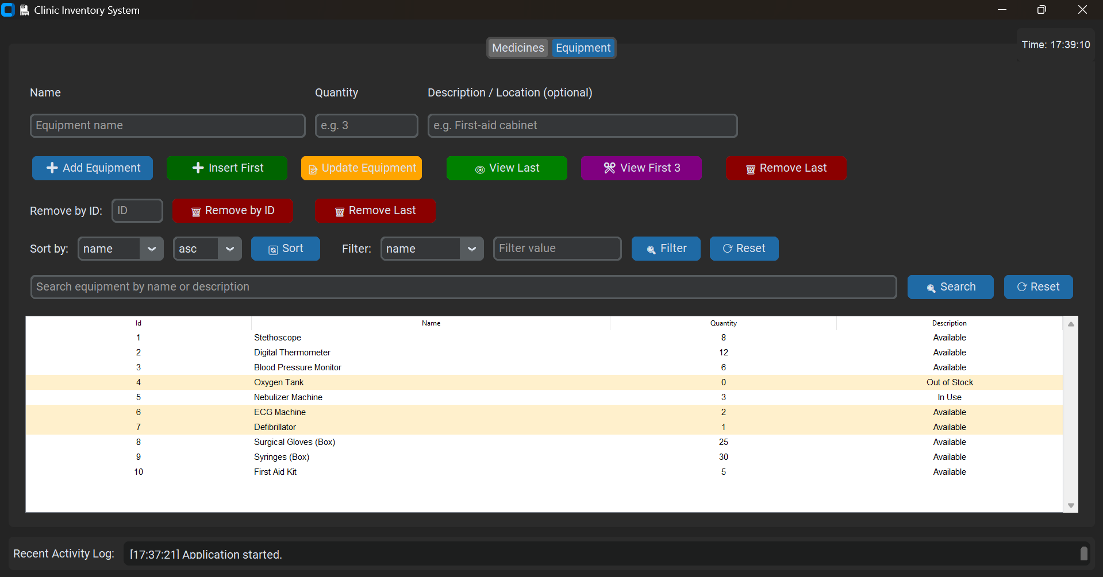
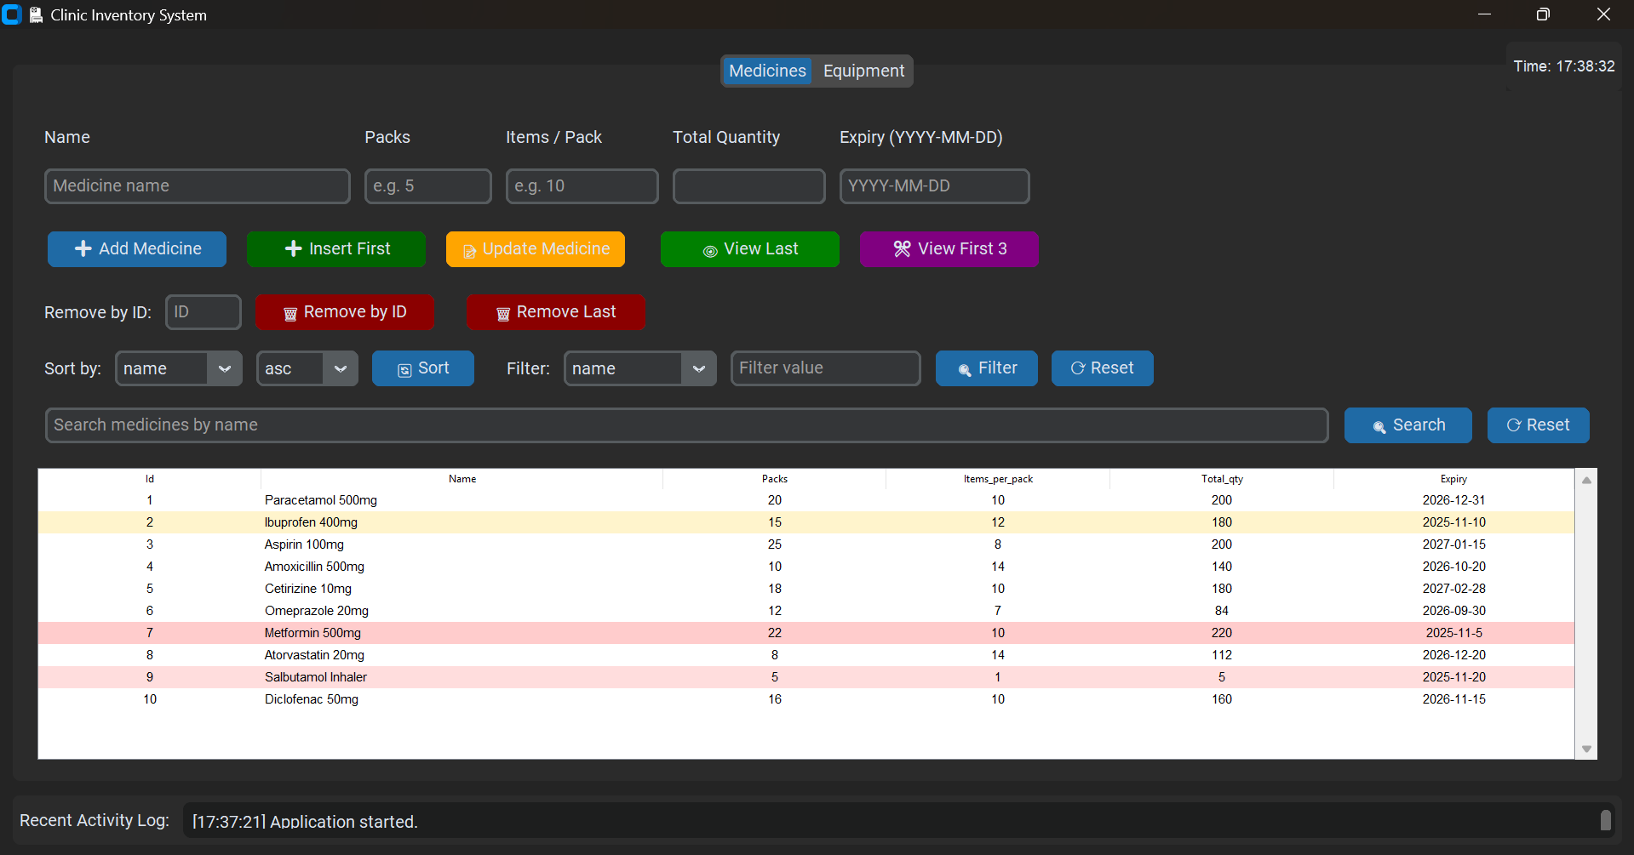

7. Conclusion:
The Clinic Inventory System provides an organized and efficient way to manage the supplies, medicines, and equipment used in a clinic. It ensures that all inventory records are properly stored, updated, and accessed when needed, helping maintain accuracy and reliability in daily operations.
This project also highlights the importance of technology in modern healthcare operations. By automating inventory tasks, clinics can save time, minimize human error, and focus more on providing quality patient care. Overall, the Clinic Inventory System demonstrates how computer-based solutions can greatly enhance the daily operations of a medical facility.
8. References
[1] GeeksforGeeks. (2025, September 10). Getting Started with Array Data Structure. https://www.geeksforgeeks.org/introduction-to-arrays-data-structure-and-algorithm-tutorials/
[2] W3Schools. (n.d.). DSA Arrays.
https://www.w3schools.com/dsa/dsa_data_arrays.php
[3] Simplilearn. (2024, [n.d.]). What Is Array in Data Structure? Types & Syntax.
https://www.simplilearn.com/tutorials/data-structure-tutorial/arrays-in-data-structure
[4] DEV Community. (2023, [n.d.]). Array Data Structure
https://dev.to/ggorantala/array-data-structure-4cl2
[5] Masai School Blog. (2021, ?). Array Data Structure – Types, Applications & Implementation.
https://www.masaischool.com/blog/array-data-structure-explained-with-examples/

